Planning Logic
Phase 4 — Sprint, Epic, Story & Velocity Logic for ISTR

Date | 12/09/2026
Student Name | Navya Sri Tangellamudi
Project Name | Intergalactic Space Travel Request System (ISTR)
Phase | Phase 4 – Project Planning (Planning Logic)

Core Concepts
Sprint: a fixed period or duration in which a team works to complete a set of tasks.
Epic: a big task or project that is too large to complete in one sprint. It is broken down into smaller tasks (Stories) that can be completed over multiple sprints. For ISTR, each Epic corresponds to one of the Functional Requirements defined in the Solution Requirements document (e.g., Approval Routing, Launch Execution).
Story: a small task that is part of an Epic. ISTR's stories are the same 15 user stories (USN-1 to USN-15) defined in the Data Flow Diagram & User Stories document.
Story Point: a number that represents how much effort a story takes to complete, usually in the form of the Fibonacci series (1, 2, 3, 5) — Very Easy, Normal, Moderate, and Difficult respectively.
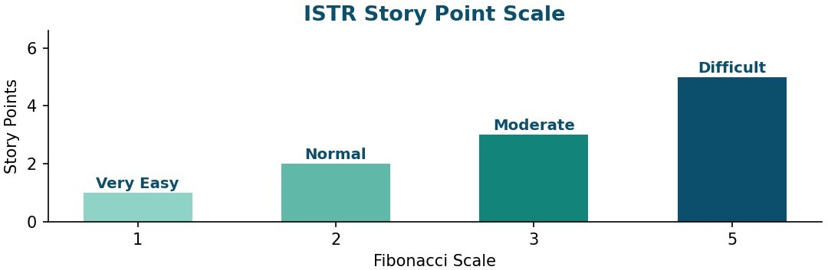
Figure 1 — ISTR Story Point Scale

Sprint 1 — Foundational Submission & Approval
Sprint 1 delivers the core path every mission request must pass through first: submission, manager notification, first-level approval, and initial budget review.

User Story ID | User Story | Story Points
Mission Request Submission |  | 5
USN-1 | Submit a Mission Request (destination, mission type, risk, cost, launch date) | 3
USN-2 | Conditional Diplomatic Officer field for Alien Negotiation missions | 1
USN-3 | Email confirmation on submission | 1
Approval Routing |  | 5
USN-5 | Auto-lookup and notify the Requester's Manager | 3
USN-6 | Manager approves/rejects with comments | 2
Budget Review |  | 2
USN-8 | Finance Officer reviews and adjusts mission cost | 2
Total Story Points — Sprint-1 |  | 12

Sprint 2 — Tracking, Escalation & Risk Review
Sprint 2 builds on that foundation with visibility features (status dashboard), the SLA escalation safety net, and the conditional Mission Control risk-review path for High/Critical missions.

User Story ID | User Story | Story Points
Mission Request Submission |  | 5
USN-4 | Live status tracking dashboard with SLA countdown | 5
Approval Routing |  | 3
USN-7 | SLA escalation reminder at 80% of duration | 3
Budget Review |  | 3
USN-9 | Finance Officer approves budget, routes onward | 3
Risk Assessment |  | 4
USN-10 | Mission Control sees only High/Critical risk queue | 2
USN-11 | Mission Control requests more info, reverts to Draft | 2
Total Story Points — Sprint-2 |  | 15

Sprint 3 — Launch & Stakeholder Visibility
Sprint 3 closes the loop: the Admin-only launch action, the audit trail, and the real-time, role-specific notifications and dashboards that keep every stakeholder informed.

User Story ID | User Story | Story Points
Launch Execution |  | 5
USN-12 | Admin triggers 'Launch Mission' UI action | 3
USN-13 | Admin views complete audit log | 2
Notifications & Dashboard |  | 7
USN-14 | Real-time notification on every state transition | 2
USN-15 | Role-specific dashboard widgets | 5
Total Story Points — Sprint-3 |  | 12

Story Points by Sprint & Epic
Plotting the same numbers by epic shows how effort shifts sprint to sprint — Sprint-1 is submission/approval-heavy, Sprint-2 carries the largest single story (the SLA-aware status dashboard), and Sprint-3 is dominated by the role-specific dashboard work.

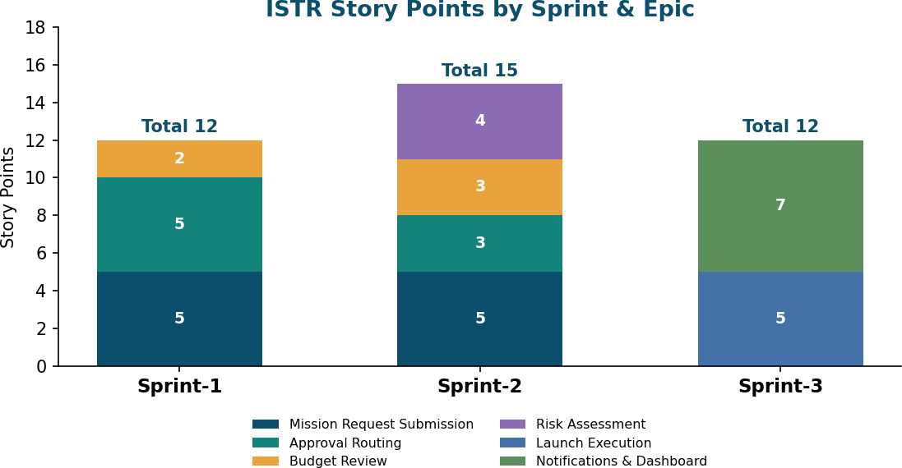

Figure 2 — ISTR Story Points by Sprint & Epic

Total Story Points & Velocity

Total Story Points — Sprint-1 | 12
Total Story Points — Sprint-2 | 15
Total Story Points — Sprint-3 | 12
Grand Total Story Points | 39
Number of Sprints | 3
Velocity (Story Points per Sprint) | 13
Velocity = Total Story Points Completed ÷ Number of Sprints
For ISTR: Velocity = 39 ÷ 3 = 13 Story Points per Sprint.
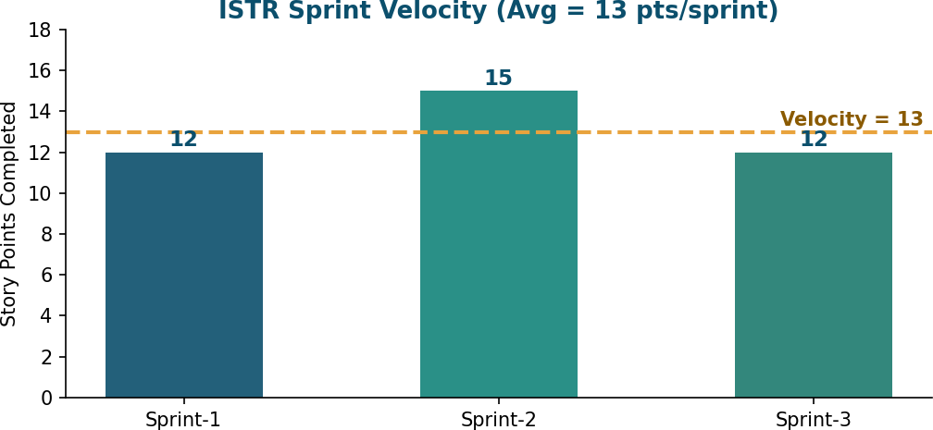

Figure 3 — ISTR Sprint Velocity

Interpretation
- ISTR's team velocity is 13 story points per sprint — this is the baseline used to forecast how many future stories (e.g., a post-launch enhancement backlog) the team can commit to per sprint.
- Sprint-2 running above the average (15 vs. 13) is explained by USN-4's size (5 points) — the SLA-aware dashboard is the single most complex story in the entire backlog alongside USN-15.
- All three sprints stay within a narrow band (12–15 points), indicating the backlog was decomposed into reasonably even, predictable chunks of work rather than a few oversized stories.

